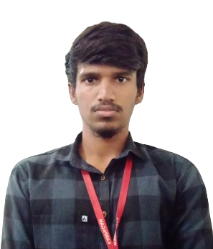**Dinesh Kanna KV**

Phone : 9361552801

Email id : [dineshkanna515@gmail.com](mailto:dineshkanna515@gmail.com)

LinkedIn : <https://www.linkedin.com/in/dinesh-kanna-839127249/>

Address: 261 ,LIG Colony ,KK Nagar ,Madurai-20

**Career Objective**

Motivated and hardworking individual with strong technical background, seeking an entry-level position to enhance my knowledge and skills for the growth of myself and the organization .

**Education**

|  |  |  |  |
| --- | --- | --- | --- |
| Qualification | Name of the Institution | CGPA/Percentage | Year of Passing |
| BE Computer Science and Design | Karpagam Academy of Higher Education | 7.9(Upto 5th Semester) | Pursuing |
| HSC | Velammal Bodhi Campus | 79 | 2021 |
| SSLC | Lakshmi School | 73 | 2019 |

**Project**

Title : Custom Web Scrapper (Price Tracker)

Description: A automation software which is used to scrap the website and tracks the price of the products listed by the user and sends notification to the user when the price hits the lowest.

**Technical Skills**

* C
* Python
* Web Designing
* SQL

**Certifications**

* Certified in Learning C by LinkedIn
* Certified on NPTEL for the below listed courses:
  + Introduction to Operating System
  + Database Management System
  + Introduction to Internet of Thing
* Certified on Infosys Springboard for the below listed courses:
  + Introduction to Artificial Intelligence
  + Introduction to Machine Learning
  + Basics of Python

**Internship**

Completed 15 days online internship in Python by Pantech E Learning.

**Area of Interest**

* AWS
* Web Designing
* Database Management

**Soft Skills**

* Strong Communication
* Quick learner
* Flexible
* Problem-solving

**Declaration**

I hereby declare that the information given above are genuine and true to the best of my knowledge and belief.

[ DINESH KANNA KV ]